***MEA Getaway at Castaway 2019***

Where**:** Detroit Lakes, MN

When: **October 17-20 2019**

Leave Thursday at **3:00 p.m.**

Return Sunday at **5:00 p.m.**

Why: Because you need to get away and be reminded *whose* you are.

Cost: $190.00 includes motor coach transportation

What to Bring: Friends, warm clothes, jacket……money for Camp Store and

food on the way up and back. New this year! Bring your own bedding and pillow>

--------------------------------------------------------------------------------------------------------------------------

*Deadline: ASAP*

Student Name:_____________________________________________________Age:_____ Grade:______

Address: _________________________________________________________________________________

School: __________________________________________________________________________________

Home Phone: _____________________________________ Cell Phone: __________________________

Parents/Guardians signature to give permission to take part in the weekend:

__________________________________________________________________________________________

Health Insurance Info: ____________________________________________________________________

Return this to: Oak Grove Lutheran Church 7045 Lyndale Richfield, MN 55423

???? call Brice at 612.998.2128

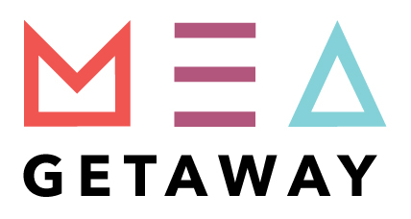

August 28, 2019

Dear Participants of MEA Getaway and Parents,

I'm sure glad you are going! It will be good for you to get away, relax, enjoy the beautiful Detroit Lakes area, and your faith will grow too. Our speaker, **Rollie Johnson** will inspire you and challenge you. We will have great music, good food, a fun program. This is a top-notch youth gathering. Castaway also has two 28-person hot tubs for us to use on the beach. So bring your swimsuit!

Castaway Club is a Young Life Camp. Young Life is an along-side-the-church organization that does outreach ministry to kids in high school and middle school.

Some things you need to know:

|  |  |
| --- | --- |
| **Where:** | Castaway Club, 51709 Co. Hwy 31, Detroit Lakes, MN 56501 Phone: 1 (218) 532-2662  Directions are easy: Go 94 West to the Fergus Falls exit (Exit 50) and take 59 North toward Detroit Lakes. Come to Pelican Lake Road (Co. Hwy. 31), take a left and go two miles to gate. (*Parents, save this in case of emergency directions!*) |
| **Time:** | We will leave via bus at **3:00 p.m.** from church on Thursday, October 17 and return at approximately **5:00 p.m.** Sunday, October 20 The church will pay for the transportation! Thank you Oak Grove! |
| **How much:** | Your total cost is **$190**– (would be $250 if you paid for transportation)  Make check out to “Oak Grove – Youth” |
| **What to bring:** | T-shirts and shorts (if warm day), warm jacket, hat, gloves, grubby clothes (one set), casual clothes (two sets), jeans and sweatshirts, toiletry articles, spending money for food up and back (McFood's, etc.) and for treats and clothes at the camp store. ($25-50). (Bedding provided—bring pillow for bus ride and if it looks like a cold weekend, bring sleeping bag or an extra blanket.) . Don't forget your swimsuit and sunglasses. **Bring sleeping bag or blanket new for 2019 to keep price the same**  Bring **warm clothes** – the wind off the lake, you know!! |

I'm glad you are going. It will be fun and you will be transformed by the spirit of the living presence of the God of the universe.

Peace,

Brice Eichlersmith

Youth & Family Pastor

P.S. Questions – give me a call (612) 998.2128

Make this information available to your friends who are going.